**LAB 3 OUTPUT**

1.Shell script to find the FACTORIAL OF A NUMBER using While Loop

echo "Enter a number"  
read num  
  
fact=1  
  
while [ $num -gt 1 ]  
do  
  fact=$((fact * num))  #fact = fact * num  
  num=$((num - 1))      #num = num - 1  
done  
  
echo $fact

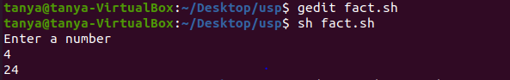

2.Shell script to perform ARITHMETIC OPERATIONS on given two numbers using Case statement syntax.  
# !/bin/bash  
echo "Enter Two numbers : "  
read a  
read b  
   
# Input type of operation  
echo "Enter Choice :"  
echo "1. Addition"  
echo "2. Subtraction"  
echo "3. Multiplication"  
echo "4. Division"  
read ch  
   
case $ch in  
  1)res=`echo $a + $b | bc`  
  ;;  
  2)res=`echo $a - $b | bc`  
  ;;  
  3)res=`echo $a \* $b | bc`  
  ;;  
  4)res=`echo "scale=2; $a / $b" | bc`  
  ;;  
esac  
echo "Result : $res"

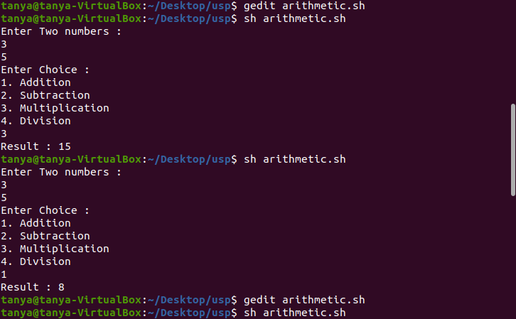

3.Shell script to find the SUM OF EVEN NUMBERS UPTO N using loop condition

echo "enter limit"  
read n  
i=2  
while [ $i -lt $n ]  
do  
sum=$((sum+i))  
i=$((i+2))  
done  
echo "sum:"$sum

